WRITE A PROGRAM print Hello with command line argument.

***Solution***:

class hello {

public static void main(String[] args) {

System.out.println("Hello " +args[0]);

}

}

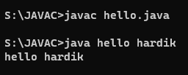

WRITE A PROGRAM implement String Functions.

***Solution***:

import java.util.Scanner;

public class strn { public static void main(String[] args) {

Scanner scanner = new Scanner(System.in);

System.out.print("Enter a string: ");

String userString = scanner.nextLine();

System.out.println("Length of String " + userString + " is: " + userString.length());

System.out.print("Enter the index for which you want index for: "); int userIndex = Integer.parseInt(scanner.nextLine());

System.out.println("Character at " + userIndex + " in " + userString + " is

" + userString.charAt(userIndex));

System.out.println(userString.replace("R","T")); }

}

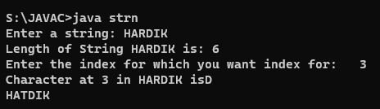

WRITE A PROGRAM find ASCII code of a given character.

**Solution:**

import java.util.Scanner; public class into {

public static void main(String[] args) { Scanner scanner = new Scanner(System.in);

System.out.print("Enter a character: "); String userString = scanner.nextLine(); char userChar = userString.charAt(0); int ascii = userChar;

System.out.println("ASCII code of " + userChar + " is " + ascii); }

}

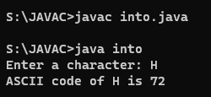

WRITE A PROGRAM swap two numbers using bitwise operator.

**Solution:**

import java.util.Scanner;

public class SwapBit {

public static void main(String[] args) {

Scanner scanner = new Scanner(System.in); System.out.print("Enter first number: "); int num1 = Integer.parseInt(scanner.nextLine());

System.out.print("Enter second number: "); int num2 = Integer.parseInt(scanner.nextLine());

System.out.println("Before swapping");

System.out.println("First number = " + num1 +"\nSecond Number = " + num2);

num1 = num1 ^ num2; num2 = num1 ^ num2; num1 = num1 ^ num2;

System.out.println("After swapping");

System.out.println("First number = " + num1 +"\nSecond Number = " + num2);

}

}

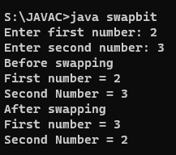

WRITE A PROGRAM check if a given alphabet is a vowel or not

using switch statement.

**Solution:**

import java.util.Scanner;

public class Vowel { public static void main(String[] args) { Scanner scanner = new Scanner(System.in); System.out.print("Enter an alphabet : ");

String input = scanner.nextLine(); switch (input.toLowerCase()) { case "a": case "e": case "i": case "o": case "u":

{

System.out.println(input + " is a vowel."); break; }

default:

System.out.println(input + " is not a vowel.");

}

}

}

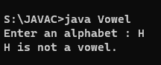

WRITE A PROGRAM N prime numbers.

**Solution:**

import java.util.Scanner;

public class primeno{ public static void main(String[] args) {

Scanner scanner = new Scanner(System.in); System.out.print("Prime Numbers till? "); int till = Integer.parseInt(scanner.nextLine());

for(int i=1; i <=till; i++){ if(isPrime(i)) {

System.out.print(i + " ");

}

} } static boolean isPrime(int n) { if(n==1||n==0) return false;

for(int i = 2; i < n; i++){ if(n%i==0) return false;

} return true;

}

}

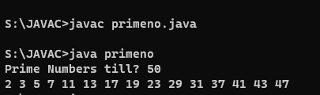

WRITE A PROGRAM to check for leap year.

**Solution:**

import java.util.Scanner; public class leapyear {

public static void main(String[] args) {

Scanner scanner = new Scanner(System.in);

System.out.println("Give a year:"); int userInput = Integer.valueOf(scanner.nextLine());

if(userInput % 4 == 0 && userInput % 100 != 0) {

System.out.println("The year is a leap year.");

} else if (userInput % 100 == 0 && userInput % 400 == 0) {

System.out.println("The year is a leap year.");

} else {

System.out.println("The year is not a leap year.");

}

}

}

